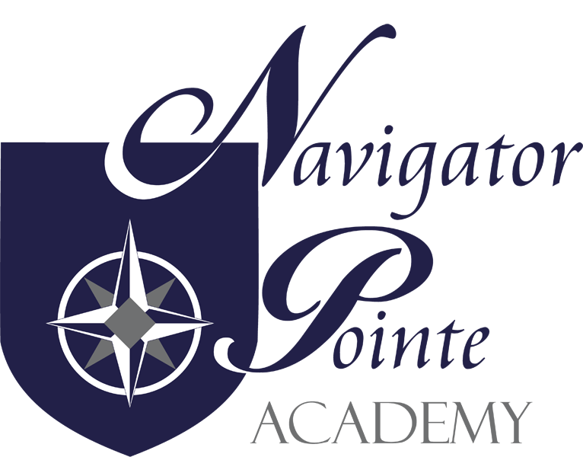
Governing Board Meeting

6844 South Navigator Drive
West Jordan, Utah

Thursday, November 16, 2017
6:00 p.m. – 7:00 p.m.
Attendance: Judy Farris, Director, Rich Eccles, Business Manager; Kristi Anderson,
Chair; Adrianne Jones; Barbara Manning; Steve Rowley

I. Call to Order/Welcome:
Welcome to Troy Backus and Steve Rowley as new board members.
Next month back to review bylaws and charter. Articles 1-4 by Barbara next
month.
II. Public Comment: none
III. Governance:
A. Board Gov. Training: “Where Do We Go From Here?” in Charter Board
University
B. Monthly Board Meeting Minutes Approval
Barbara moved to approve the October 2017 minutes as amended. 2nd by
Adrianne Roll: Barbara: yes; Kristi: yes; Steve: abstain; Adrianne: yes
C. “Closed Session, as necessary, to discuss allowed items” N/A
IV. Director’s Report: Navigator Pointe Academy Data Governance Plan distributed for
feedback. Final version in process.
A. Enrollment: Lost one student that was commuting a long way.
Preparing to turn out re-enrollment for next year in a few weeks.
B. Volunteerism: Slightly higher than usual.
Fun Run total reported.
C. Student Achievement: In the middle of benchmarks assessment.
Completed beginning of year DIBELS
Lexia for at risk K-3 and seeing some progress though it is still early.
Personal Growth: Veteran Salute was off the charts! 36 Veterans
Lots of food collected for Veteran’s pantry.
Character development is alive and well.

V. Financial Report:
Barbara moved to accept the October 2017 financials. 2nd by
Adrianne Roll: Barbara: yes; Kristi: yes; Steve: yes; Adrianne: yes
VI. Next Meeting Schedule: Third Thursday is on Christmas Break. Meeting will be
December 14th at 6:00 without financials as they will not be ready that soon.
VII. Adjourn: Barbara moved to adjourn at 7:02. 2nd by Steve Roll: Barbara: yes; Kristi:
yes; Steve: yes; Adrianne: yes

