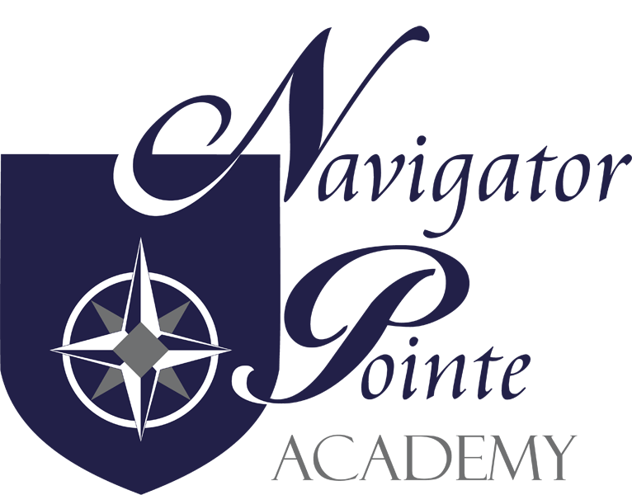

STUDENT COMPUTER USE POLICY

I. Board Policy
The Board recognizes the need for a policy governing the use of school computers and use of electronic information resources by students as outlined in Utah State Code §53A-3-422 and the Children’s Internet Protection Act (Pub.L.No. 106-554). Policies and procedures are established for the protection of students and equipment. Responsibility is delegated to the School Administration and teachers for implementing the policy according to established guidelines. Students are accountable for following established policies.
II. Administration Policy
A. Scope
This policy references the use of computers and the use of electronic information resources made available to students by Navigator Pointe Academy. Student use of electronic information resources must be in support of education and research and consistent with the educational objectives of Navigator Pointe Academy. While access to all materials on a worldwide network cannot be controlled, Internet access in the school is monitored on an ongoing basis.
The Acceptable Use Policy shall be administered and implemented according to the following terms and conditions:
B. Acceptable Network Use
1. Students will use the Internet and other electronic information resources in an appropriate manner, abiding by the rules and regulations described in this policy and in the Navigator Pointe Academy Internet Safety Policy.
2. Students are expected to abide by generally accepted rules of network etiquette. These rules include, but are not limited to, being polite, never sending or encouraging others to send abusive messages, and not using inappropriate language.
3. Safety Guide
a. Computer use and communication shall always be at the direction and with the supervision of a teacher or paraprofessional
b. Never provide online personal information including last name, address, telephone number, school name, and social security number
c. Never respond to, and always report to the teacher or parent, any messages that make you feel uncomfortable or that are from an unknown origin.
d. Never send a photo of yourself or anyone else.
e. Never arrange a face-to-face meeting with someone you meet on line.
f. Never open attachments or files from unknown senders.
g. Always report to a teacher any inappropriate sites that you observe being accessed by another user or that you browse to accidentally.
C. Prohibited Conduct, includes but is not limited to, accessing, sending, creating or posting material or communications that are:
1. Illegal
2. Damaging to another person's reputation
3. Abusive
4. Obscene
5. Sexually oriented
6. Threatening or demeaning to another person
7. Contrary to the school's policy on harassment
8. Harassing or Bullying
9. Unapproved by NPA staff
D. Prohibited Uses, includes, but is not limited to the following uses:
1. Accessing Social networking sites
2. Using the network for financial gain or advertising.
3. Posting or plagiarizing work created by another person without his/her consent.
4. Posting anonymous or forging electronic mail messages.
5. Attempting to read, alter, delete, or copy the electronic mail messages of other system users.
6. Giving out personal information such as phone numbers, addresses, driver's license or social security numbers, bankcard or checking account information.
7. Using the school's computer hardware or network for any illegal activity such as copying or downloading copyrighted software, music or images, or violation of copyright laws.
8. Downloading, installing, or using games, music files, public domain, shareware or any other unauthorized program on any school's computer or computer system.
9. Purposely bringing on premises or infecting any school computer or network with a Virus, Trojan, or program designed to damage, alter, destroy or provide access to unauthorized data or information.
10. Gaining access or attempting to access unauthorized or restricted network resources or the data and documents of another person.
11. Using or attempting to use the password or account of another person or utilizing a computer while logged on under another user's account.
12. Using the school's computers or network while access privileges have been suspended.
13. Using the school's computer hardware, network, or Internet link in a manner that is inconsistent with a teacher's directions and generally accepted network etiquette.
14. Altering or attempting to alter the configuration of a computer, network electronics, the operating system, or any of the software.
15. Attempting to vandalize, disconnect or disassemble any network or computer component.
16. Utilizing the computers and network to retrieve information or run software applications not assigned by their teacher or inconsistent with school policy.
17. Providing another student with user account information or passwords.
18. Connecting to or installing any computer hardware, components, or software which is not school system property or part of the school’s technology resources.
19. Bringing on premises any disk or storage device that contains software network equipment to scan or probe the network, or provide access to unauthorized areas or data.
20. Downloading or accessing via e-mail or file sharing, any software or programs not specifically authorized by school.
21. Bypassing or attempting to circumvent network security, virus protection, network filtering, or policies.
22. Possessing or accessing information on school property related to "Hacking", or altering, or bypassing network security or policies.
23. Under the supervision of a teacher or other professional, students may use the school computer system only for legitimate educational purposes, which include class work and independent research that is similar to the subjects studied in school.
24. Participating on message boards or chat rooms.
25. Students shall not access entertainment sites, such as social networking sites or gaming sites.
26. All student use of the school network and Internet system or personal cell phones or other digital devices used by students while on campus are subject to the provisions of the individual school policies.
27. Students should follow the guidelines for searching that utilize safe search engines and technology.
E. Off Campus Internet Expression
1. Students may be disciplined for expression on/off campus networks or websites only if the expression is deemed to cause a substantial disruption in school, or collide or interfere with the rights of other students, staff or employees.
2. Students maintaining or posting material to a Web site or blog that threatens a likelihood of substantial disruption in school, including harming or interfering with the rights of other students to participate fully in school or extracurricular activities is a violation of the Appropriate Use Policy and can subject the student to appropriate penalties and disciplinary action.
F. Expectation of Privacy
1. Student files, disks, documents, transmissions, etc., which have been used or created with school electronic information resources are not considered private
G. Discussion/Submission
1. Students will participate in a discussion with a parent/legal guardian concerning Internet Safety and Student Computer Use Policies, which include proper behavior and use of the Internet.
2. Students will annually, participate in a teacher-led discussion on Internet Safety and Student Computer Use Policies
3. Students will be required to submit a new Student Signature of Agreement Form each year or upon special request.
H. Student Accountability
1. The combined signatures indicate that the student and parent/legal guardian have carefully read, understand and agree to abide by these terms and conditions regarding proper behavior and use of the network. The signatures on the Student Signature Agreement Form are legally binding.
2. Students who violate the terms and conditions of this policy will be subject to disciplinary action, including the possibility of suspension or expulsion from school and appropriate legal action. Access to electronic information may be limited, suspended or revoked.

I. Service Disclaimer
1. Navigator Pointe Academy makes no warranties of any kind, either expressed or implied, for the electronic information resources it is providing. The school will not be responsible for any damages a student suffers while using these resources. These damages may include, but are not limited to, loss of data as a result of delays, employee errors or omissions, or non-deliveries or service interruptions caused by a network system. Use of information obtained by the network system is at the student’s risk. Navigator Pointe Academy specifically denies any responsibility for the accuracy of information obtained through the electronic information resources.

Admin/Admin/200 (Policy & Procedure)/Student Computer Use/08112015SP

INTERNET SAFETY AND STUDENT COMPUTER USE AGREEMENT
AND ACCEPTANCE OF POLICY

DIRECTIONS:
1. READ THE INTERNET SAFETY AND STUDENT COMPUTER USE POLICIES.
2. SIGN AND RETURN THIS AGREEMENT PAGE TO THE SCHOOL OFFICE.
3. KEEP THE “INTERNET SAFETY POLICY” AND “STUDENT COMPUTER USE POLICY” FOR YOUR REFERENCE.

PARENT/LEGAL GUARDIAN:
I have read the Navigator Pointe Academy (“NPA”) Internet Safety Policy and the Student Computer Use Policy and have reviewed and discussed these policies with my student, of whom I am the parent/legal guardian. I understand that violation of the use provisions stated in the policies may result in use limitation, suspension or revocation and/or disciplinary actions by NPA, or by legal authorities, including the possibility of suspension or expulsion from school and/or appropriate legal action. I further understand that my student is legally responsible and financially liable for damage to computers or other equipment caused by his/her willful and/or negligent behavior. As the below named student’s parent/legal guardian, I accept that responsibility, liability, and all terms of these policies.

Parent’s/Guardian’s Printed Name: _________________________________________________

Parent’s/Guardian’s Signature: ____________________________________________________

Date: ___________________

STUDENT:
I have read (or have had read to me) the Navigator Pointe Academy (NPA”) “Internet Safety Policy” and “Student Computer Use Policy and have reviewed and discussed these policies with my parent/legal guardian. I understand that violation of the use provisions stated in these policies may result in use limitation, suspension or revocation and/or disciplinary actions by NPA, or by legal authorities, including the possibility of suspension or expulsion from school and/or appropriate legal action. I further understand that I am legally responsible and financially liable for damage to computers or other equipment caused by my willful and/or negligent behavior. I accept that responsibility, liability, and all terms of these policies.

Student’s Printed Name: _________________________________________________

Student’s Signature: ____________________________________________________

Date: ___________________

