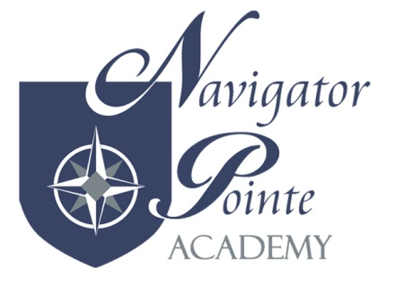
NUTRITION AND WELLNESS POLICY

Purpose and Philosophy:

To optimize student performance potential, Navigator Pointe Academy promotes a healthy school by supporting wellness, good nutrition, and regular physical activity as part of the total learning environment. Navigator Pointe Academy supports a healthy environment where children learn and participate in positive dietary and lifestyle practices. Navigator Pointe Academy seeks to contribute to the basic health status of children by facilitating learning through the support and promotion of good nutrition and physical activity.

Opportunities for Physical Education and Physical Activity

A quality physical education program is an essential component for student health and learning. A sequential developmental appropriate curriculum shall be utilized to help students develop the knowledge, motor skills, self-management skills, attitudes and confidence needed to adopt and maintain physical activity through their lives, consistent with the State Core Physical Education Curriculum. Physical activity includes regular instructional physical education and participation in indoor and outdoor programs.

Opportunities for Nutrition Education

Nutrition education topics shall be integrated within the school’s lunch program, science program, physical education program and other subjects at each grade level. Nutrition education shall focus on students’ eating behaviors, lifestyle, and nutritional science, based on theories and methods proven effective by published research and consistent with the State Core Physical Education and Health Education Curriculum. Health Science and P.E. teachers will develop and implement monthly lesson plans in accordance with this policy.

