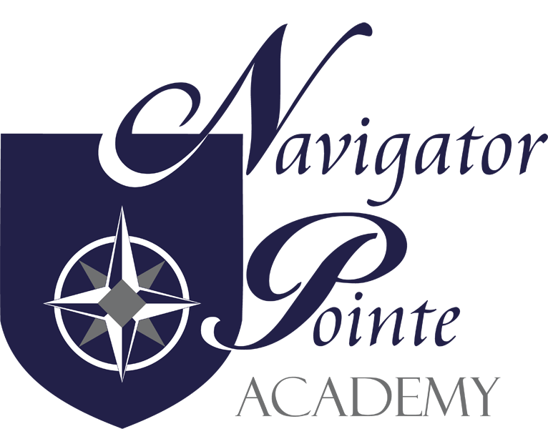

GANG PREVENTION AND INTERVENTION POLICY

Governing Board Policy

It is the policy of Navigator Pointe Academy to prohibit gang activity and similar destructive or illegal group behavior on school property or at school-sponsored functions.

1. Definitions

1.1 “Gang” (as defined in this rule) means a group of three or more people who form an allegiance and engage in a range of anti-social behaviors that may include violent or unlawful activity or both. These groups may have a name, turf, colors, symbols or distinct dress, or any combination of the preceding characteristics.

1.2 “Gang Prevention” means instructional and support strategies, activities designed and implemented to provide successful experiences for youth and families. These components shall promote cultural and social competence, self-management skills, citizenship, preparation for life skills, academic achievement, literacy, and interpersonal relationship skills required for school completion and full participation in society.

1.3 “Gang Intervention” means support services required by an individual student experiencing difficulty in cultural and social competence, self-management skills, citizenship, preparation for life skills, academic achievement, literacy and interpersonal relationships within or outside of the school which may impact the individual’s susceptibility to gang membership or gang-like activities or both.

2. Goals

The intent of this policy is to help NPA staff, students and families to:

2.1 Provide immediate access to gang prevention and intervention information and resources including
Gangfree.Utah.Gov
Salt Lake Metro Gang Unit

2.2 Understand the meanings of “criminal gang” and “criminal gang activity”: the myths and facts; risks and protective factors; warning signs and clues; and appropriate interventions steps

2.3 Educate school personnel, parents, and students about effective prevention and intervention

2.4 Establish school-based protocols for prevention, and intervention

2.5 Build connections with the community and support services

2.6 Provide access to local resources to educate parents and teachers

2.7 Provide training for the school safety team and staff in an annual
school gang prevention/intervention training to include early warning signs

3. Prohibited Gang Activities

For the purposes of this policy, prohibited “gang activities” include, but are not limited to any of the following:

3.1 Advocating or promoting a gang or any gang-related activities

3.2 Soliciting and/or initiating others for membership in a gang

3.3 Requesting any person to pay for “protection”, claiming “turf” or otherwise
intimidating, bullying, retaliating against, threatening, or harassing any person

3.4 Encouraging or inciting another person to act with physical violence upon any other person or cause damage to property

3.5 Marking school property, books, or school work with gang names, slogans or signs

3.6 Gang-related graffiti or damage to school property

3.7 Displaying or wearing, possessing, using, distributing, displaying, or selling any clothing, jewelry, apparel, emblems, badges, tattoos or manner of grooming, accessories, symbols, signs, or other thing which is evidence of membership in or affiliation with any gang that is disruptive to the school environment. Recognizing that gang styles and clothing continually evolve and change, and that no list could comprehensively define all clothing affiliated with gangs, a representative list provided by local law enforcement will be used

3.8 Communicating in any method, including verbal, non-verbal, and electronic means (flashing signs, gestures, hand-shakes, texting, etc.) designed to convey gang membership or affiliation

4.0 Reporting Gang Activities

4.1 School faculty and personnel and students shall report suspected gang activities relating to the school and its students to a school administrator or law enforcement

4.2 A student who participates in gang activities will be subject to the Navigator Pointe Academy School Discipline Policy (4.5.1), in addition to legal consequences

4.3 Gang related graffiti or damage to school property shall result in parent or guardian notification and appropriate administrative and law enforcement actions, which may include obtaining restitution from those responsible for the damage

4.4. If a serious gang-related incident, as determined by the school administrator in consultation with local law enforcement, occurs on school property, at school related activities, or on a site that is normally considered to be under school control, notification shall be provided to parents and guardians of students in the school:

4.4.1 informing them, in general terms, about the incident, but removing all personally identifiable information about students from the notice

4.4.2 emphasizing the school’s concern for safety and

4.4.3 outlining the action taken at the school regarding the incident

5.0 School faculty and staff shall receive training on the implementation of this policy, recognition of the early warning signs of gang involvement, and strategies to help students resist involvement with gangs or mimicking gang behavior.

Admin/Admin/Policy & Procedure/Gang Prevention and Intervention Policy/11317SP

