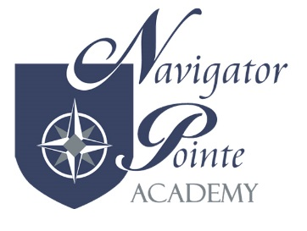
SUICIDE PREVENTION, INTERVENTION, AND POSTVENTION POLICY
- PURPOSE
The intent of this policy is to help NPA staff, students and families to:
- Create immediate access to suicide prevention information
- Understand the nature of youth suicide: the myths and facts; risks and protective factors; warnings, signs, and clues; and appropriate intervention steps
- Educate school personnel, parents, and students about effective suicide prevention and intervention
- Establish school-based protocols for suicide prevention, crisis intervention
- Build connections with the community and among regional support services and
- Provide access to local resources
NOTE: Quoted from the Utah K-12 School-Based Suicide Prevention Manual
- RESOURCES
2.1 Designate the school psychologist, school counselor, Special Education Coordinator and School Director as the team to oversee the suicide prevention, intervention, and postvention program
2.2 Use the Utah Suicide Prevention Intervention and Postvention for K-12 Schools Manual as a guide to implement a suicide prevention, intervention, and postvention program for secondary students
2.3 Inform school personnel, students and parents about the School Safety and Crisis Hotline
Contact Information:
UNI CrisisLine
801-587-3000
Email: mailto:uni.crisis@hsc.utah.edu

- TRAINING
3.1 All licensed educators must complete two hours of professional development of youth suicide prevention training once every license renewal cycle.
3.2 All additional staff will participate in an annual school suicide prevention training

- REPORT PROGRESS
4.1 Report annual implementation progress to NPA Board
4.2 Report annual implementation progress to the Utah legislature’s Iterim Education committee as requested
Admin/Admin/200(Policy&Procedure)/SuicidePrevention/08052015SP

