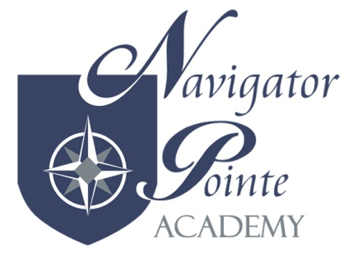
Child Abuse Reporting by Education Personnel
Policy & Procedures

- PURPOSE AND PHILOPSOPHY

School personnel have a responsibility to report suspected abuse or neglect of a child. The Navigator Pointe Academy Board adopted this policy to provide clear understanding and direction to school personnel in regard to universal, effective and sensitive handling of child abuse referrals.

- POLICY

Utah law requires that whenever any person, including any school employee, has reason to believe that a child has been subjected to incest, molestation, sexual exploitation, sexual abuse, physical abuse, or neglect, or observes a child being subjected to conditions or circumstances which would reasonably result in such, he/she shall immediately notify the nearest peace officer, law enforcement agency, or office of the Division of Child and amily Services (DCFS).

- CHILD ABUSE REPORTING PROTOCOL

  - The Director shall distribute annually to all school employees copies of the District’s procedures for reporting suspected child abyse or neglect and the Child Abuse-Neglect Reporting Forms.
  - If there is reason to believe that a child may have been subjected to abuse or neglect, an oral report shall be made immediately by the school employee reporting the abuse/neglect with a written report to follow within 24 hours.
    - When making the oral report, always have the person you notify identify himself/herself. The notified person’s name shall be entered on the written report.
    - A copy of the written report shall be placed in a separate file to be maintained by the principal, for all reported cases of suspected child abuse or neglect.
    - The Child Abuse-Neglect Reporting form shall not be placed in the student’s personal education file.

  - It is not the responsibility of principals or other school employees to prove that the child has been neglected, or to determine whether the child is in need of protection.
    - Investigation by staff prior to submitting a report shall not go beyond that necessary to support a reasonable belief that a reportable problem exists.
    - To determine whether or not there is reason to believe that abuse or neglect has occurred, professional school employees may (but are not required to) gather information only to the extent necessary to determine whether a reportable circumstance exists.
    - Interviews with the child or suspected abuser shall not be conducted by administrators or school employees.
    - Notes of voluntary or spontaneous statements by the child shall be made and given to the investigating agency.
    - Principals, school employees, DCSF, and law enforcement personnel are required to preserve the anonymity of those making the initial report and any others involved in the subsequent investigation.
    - Investigations are the responsibility of DCFS.
[a] Principals or other school employees shall not contact the parents, relatives, friends, neighbors, etc. for the purpose of determining the cause of injury and/or apparent neglect.
[b] School officials shall cooperate with social service and law enforcement agency employees authorized to investigate reports of alleged child abuse and neglect, including:
(i) allowing appropriate access to interview a child consistent with the investigating agency’s protocols; and
(ii), assisting as asked as members of interdisciplinary child protection teams in providing protective diagnostic, assessment, treatment, and coordinating services.
    - Persons making reports or participating in good faith in an investigation of alleged child abuse or neglect are immune from any civil or criminal liability that otherwise might arise from those actions.

DEFINITIONS
“Abuse” the policy that uses the definition of abuse found in Utah Code Ann. §78A-6-105(1).
“Neglect” this policy uses the definition of neglect found in Utah Code Ann. §78A-6-105(35).
REFERENCES
Utah Code Ann. §53E-6-701- Mandatory reporting of physical or sexual abuse of students.
Utah Code Ann. §62A-4a-403 – Reporting requirements.
Utah Administrative Code R277-401 – Child Abuse-Neglect Reporting by Education Personnel.

