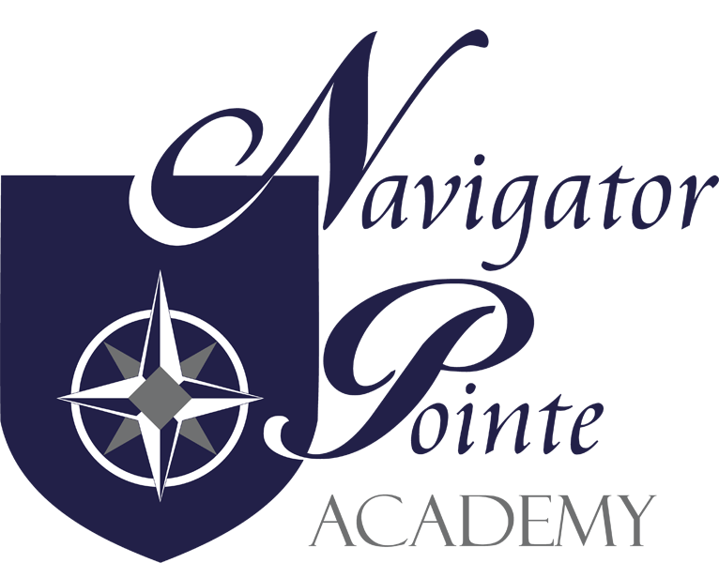

RELIGIOUS FREEDOM POLICY

Governing Board Policy

1. Purposes and Philosophy

1.1 The Navigator Pointe Academy Board (NPA) recognizes, protects and accommodates the rights of religious practice and expression guaranteed by state and federal laws, and by the constitutions of Utah and the United States of America.

1.2 The purpose of this policy is to protect and accommodate the rights of conscience and exercise of religious freedom of students, parents/guardians and employees.

1.3 NPA promotes mutual understanding and respect for the interests and rights of
all individuals regarding their beliefs, values, and customs. Specifically it is
the school’s purpose to have a policy that:

1.4 Fosters knowledge and understanding about religious differences and the role of religion in a diverse society;

1.5 Supports a climate of academic freedom in which religious ideas and organizations can be discussed in an objective way, for their educational value, with emphasis on the impact of religions on history, literature, art, music, morality, and other key social institutions;

1.6. Requires official neutrality on the part of administrators, teachers, other
employees, and volunteers regarding religious activity when acting in their
official capacities;

1.7 Promotes constructive dialogue between schools and community regarding
religion and encourages all to resolve problems over religious issues in schools promptly, equitably, and with civility at the local level;

1.8 It is the school policy to meet the provisions of the Utah Code 53A-13-101.1-3
and the Utah Administrative Code R277-105-9

2. Religion in the Curriculum

2.1 Teaching about religion: Religious instruction is the responsibility of parents and religious institutions, but teaching about religion and beliefs of conscience is a legitimate and appropriate part of a complete academic education on the elementary and secondary levels. The educational approach to religion is one of academic instruction, not indoctrination, and will not unduly favor non-religion over religion.

2.2 Any instructional activity, performance or display including examination
of, or presentations about religion, political or religious thought or expression, or the influence thereof on music, art, theater, literature, law, politics, history, science, or any other element of the curriculum, including the comparative study of religions, which is designed to achieve secular educational objectives included within the context of a course or activity and conducted in accordance with applicable rules of the state and the NPA board, may be undertaken.

2.3 No aspect of cultural heritage, political theory, moral theory or societal value shall be included within or excluded from public school curricula for the primary that it affirms, ignores, or denies religious belief, religious doctrine, a religious sect, or the existence of a spiritual realm or supreme being.

3. Requests for Waiver of Participation

3.1 Rights of individuals: While NPA acknowledges its obligation to be just toward the personal rights and beliefs of all individuals, merely exposing students to ideas that may offend the religion does not amount to a substantial burden on their religious exercise. Furthermore, it is unconstitutional to allow one person’s or group’s religion to determine the curriculum for all others. Consequently, it is NPA’s policy to accommodate the legitimate objections of individuals by granting waivers of participation when requested or when no other reasonable alternative is possible.

3.2 A parent or a legal guardian of a student may request a waiver of participation in any portion of the curriculum or school activity which the requesting party believes to be an infringement upon a right of conscience or the exercise of religious freedom in any of the following ways:

3.2.1 It would require participation in a practice that would be offensive to or
substantially burdensome on a religion;

3.2.2 It would require participation in a practice forbidden by a religious belief or practice, or right of conscience; or

3.2.3 It would bar participation in a practice required by a religious belief or practice, or right of conscience

3.3 A claimed infringement must rise to a level of belief that the school requirement violates a superior duty that is more than personal preference.

3.4 A parent or legal guardian requesting a waiver of participation my also suggest an alternative to the school requirement or activity that requires reasonably equivalent performance by the student.

3.5 In responding to a request for a waiver, the school may:

3.5.1 Waive participation by the student in the objectionable curriculum or activity, with no penalty;

3.5.2 Provide a reasonable alternative as suggested by the parent, or other reasonable alternative developed in consultation with the requesting party, that will achieve the objectives of the portion of the curriculum
or activity for which waiver is sought; or

3.5.3 A request for waiver shall not be denied unless school officials determine that requiring the participation of the student is the least restrictive means necessary to achieve a compelling school interest.

3.5.4 In responding to a request for waiver, the school shall not require a student to accept a substandard or educationally deficient alternative.

3.5.5 If any portion of any curriculum or activity is repeatedly alleged to
interfere with the rights of conscience or exercise of religious freedom
of students, parents or legal guardians, such curriculum or activity shall be evaluated by the school director and curriculum coordinators to determine whether the educational objectives could be achieved by less intrusive means.

4. Religious Neutrality

4.1 NPA officials and employees may not use their positions to endorse, promote, or disparage a particular religious, denominational, sectarian agnostic, or atheistic belief or viewpoint.

4.2 NPA officials and employees may not sponsor prayer or religious devotionals.

5. Student Expression of Personal Religious Beliefs or Views

5.1 Non-discrimination: NPA will not forbid students acting on their own from expressing their personal religious views or beliefs solely because they are of a religious nature and will not discriminate against private religious expression by students, but will instead give students the same right to engage in religious activity and discussion as they have to engage in other comparable activities.

5.2 Freedom to act: While the freedom to believe is absolute, the freedom to act on a belief is not. In order to claim a violation of the Free Exercise protections of the First Amendment and this policy, a person must show that his or her actions 1) are motivated by a sincere religious belief, and 2) have been substantially burdened by school officials or NPA.

5.3 Least restrictive means: If an individual can show that his or her actions are motivated by a sincere religious belief and have been substantially burdened by school officials or the school, school officials can still regulate the conduct if they have a compelling interest and pursue such interest in the manner least restrictive of the individual’s religion.

5.4 Student religious expression during instructional time:
Students participating in school sponsored learning activities shall not be prohibited from expressing personal religious beliefs or be penalized for so doing, unless the expression unreasonably interferes with the ability of school official to maintain safety, order and discipline, vilolates school rules, impinges on the rights of others, unreasonably endangers persons or property, creates a coercive atmosphere or violates concepts of civility or propriety appropriate to the school setting.

5.4.1 Student religious conduct or expression that may not be prohibited in homework, classroom discussions, presentations, assignments, or school sponsored activities, unless it violates the standards above, includes but is not limited to:

5.4.1.1 [a] Submitting homework, artwork, or other assignments with religious content;

5.4.1.2 [b] Giving class presentations with religious content that are relevant to the curriculum matter being discussed;

5.4.1.3 [c] Making religious remarks or asking questions about religion in the ordinary course and relevancy of a classroom discussion;

5.4.1.4 [d] Asking questions of students or school employees regarding
their religious beliefs or views.

5.4.2 Teachers and other school officials should evaluate homework and classroom work with religious content consistent with ordinary academic standards of substance and relevance, as well as other legitimate pedagogical concerns.

5.5 Student religious expression during discretionary time: Enrolled students may initiate and conduct voluntary religious activities or otherwise exercise their religious freedom during discretionary time shall not be denied unless the conduct or speech unreasonably interferes with the ability of school officials to maintain safety, order and discipline, violates school rules, impinges on the right of others, unreasonably endangers persons or property, creates a coercive atmosphere, disrupts, or violates concepts of civility or propriety appropriate to the school setting.

5.5.1 Student conduct or speech of a personal, religious nature that may not be prohibited unless it violates the standards above, includes, but is not limited to:

5.5.1.1 [a] Reading the Bible or other scriptures

5.5.1.2 [b] Saying grace before meals

5.5.1.3 [c] Praying individually or with student(s), in the multi-purpose room, hallways, or student-accessible areas of the school.

5.5.2 School employees may neither conduct nor actively participate in the
student activities, but may ensure proper observation of school rules.

6. Employee Expression of Personal Religious Beliefs

6.1 Official neutrality: All employees of NPA must maintain strict neutrality when acting in their official capacities. An employee’s right relating to voluntary religious practices and freedom of speech do not include proselytizing of any student regarding atheistic, agnostic, sectarian, religious, or denominational doctrine while the employee is acting in the employee’s official capacity, nor may an employee attempt to use his or her position to influence a student regarding the student’s religious beliefs or lack thereof.

6.2 Employees that want to pray or meet with other adult employees for religious activities need to do so outside the presence of students and the activities must not interfere with their employment duties or the rights of other employees.

6.3 Response to questions: If a student asks an employee about that employee’s personal religious beliefs, the employee may choose not to respond out of professional respect for the student’s freedom on conscience or personal beliefs. However, while acting in an official capacity, an employee may respond.

7. Supervision and Training

7.1 The NPA Board and its employees shall cooperate and share responsibilities in implementing this policy.

7.2 The training to implement this policy will take place during the annual NPA summer in-service

7.3 Parents and legal guardians shall be notified annually of their rights under this policy. A copy of this policy will be included is available on the school website, www.npacademy.org, or upon request at the school office.

